**Call for Code 2019 - <Anthem Technocrats> Deadline – 06/07/2019**

**Project Title**

Water Scarcity Prediction Using AI

**Project Description**

Artificial intelligence can predict where conflicts over scarce water will break out up to a year in advance and allow action to prevent them.

**Current Problem -**

The water crisis has become one of the major concerns across the globe. As only less than one percent of earth surface water is suitable for human consumption, it becomes crucial that we save water so that our future generations survive. The unchecked use of water and extreme weather conditions have worsened the situation and in no time there will be a fresh water shortage, irregularities in supply and demand, groundwater shrinkage, among other challenges. Water scarcity affects drinking water supply, electricity generation, food and industrial production. Furthermore, droughts pose a severe threat to livelihoods. Thus, conflicts and destabilization of governments, which are not able to take care of fair and sufficient water distribution to everything seem to be a major consequence.

**Solution Description -***Based on historical data collected on ground water level and it’s usage, climatic changes, population and industrial usage we can predict the possibilities of upcoming water scarcity issues. We can also suggest solutions to avoid the same.*

**Included Components -**

*Machine Learning*

**Featured Technologies -**

*.Net, Pipeline ML algorithm*

**Architecture Diagram -**

Process the input data based on trained data using ML

**Steps -**

* *Detailed steps to setup your project (Include screenshots/video link if possible)*
* *Deployed Application Link*

1. *Open your browser and download the solution zip file from the below path.*
2. [*https://github.com/arulkumar2cognizant/AnthemTechnocarts/blob/master/AnthemTechnocrats.zip*](https://github.com/arulkumar2cognizant/AnthemTechnocarts/blob/master/AnthemTechnocrats.zip)
3. *Once completed download extract the zip file, open the debug folder ~/AnthemTechnocrats.zip\AnthemTechnocrats\ClaimDecisionMaking\bin\Debug*
4. *Open ClaimDecisionMaking.exe*
5. *Select city and enter the year to predict, once prediction completed result will be displayed below submit.*

***Screenshots:***

1. *Once run the application it will open like below image,*

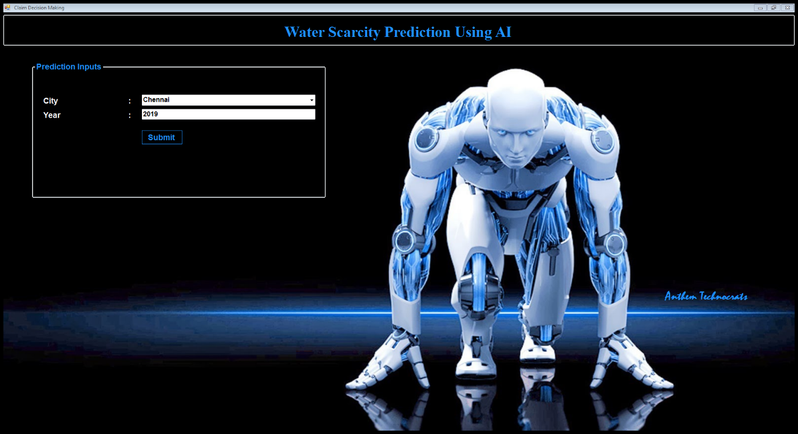

*2. After prediction result will be like,*

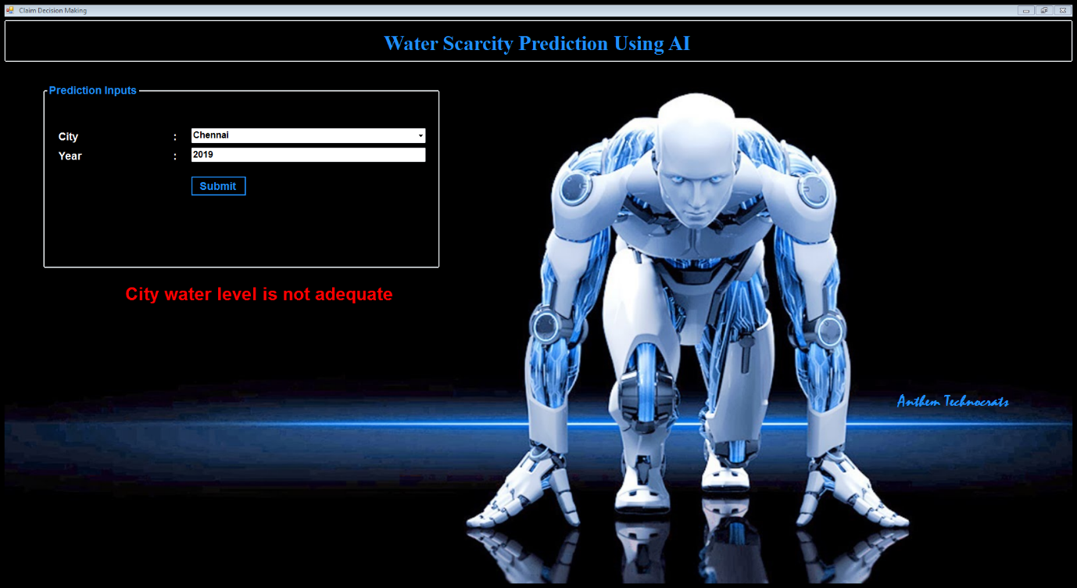

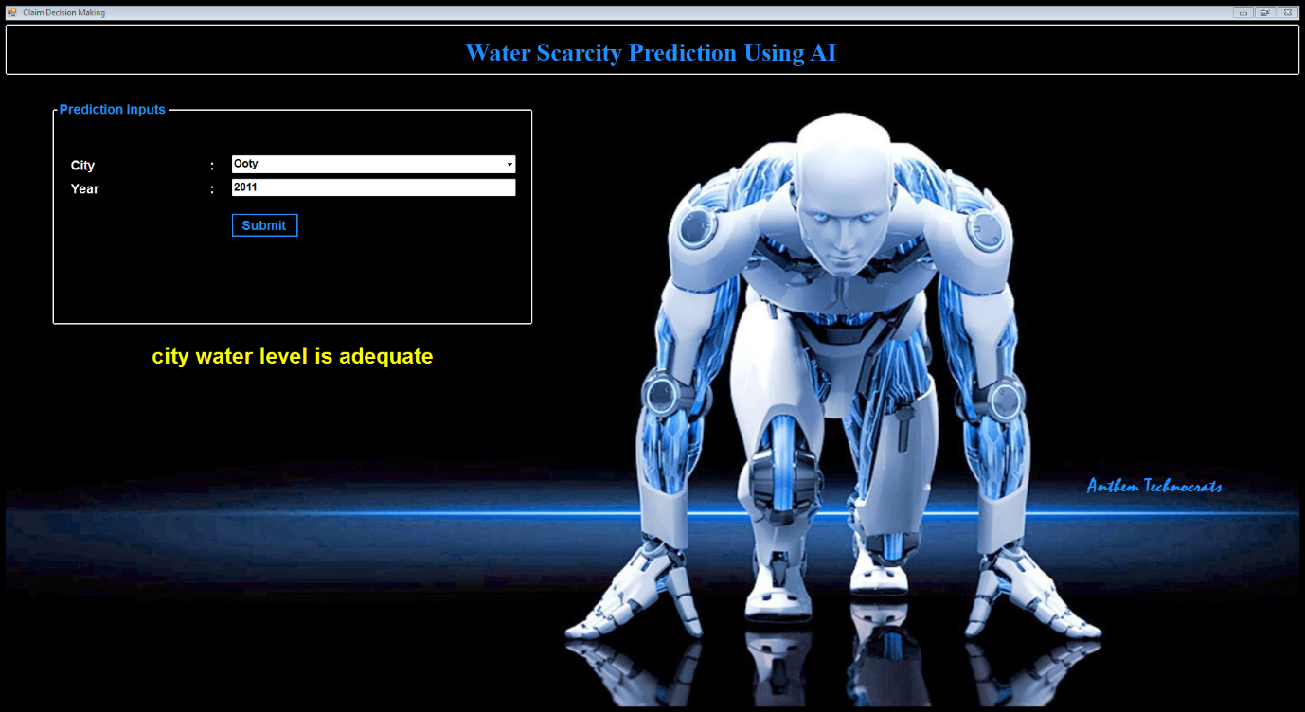

**Results -**

*Based on the prediction identify the city water level and prevent water scarcity in future.*